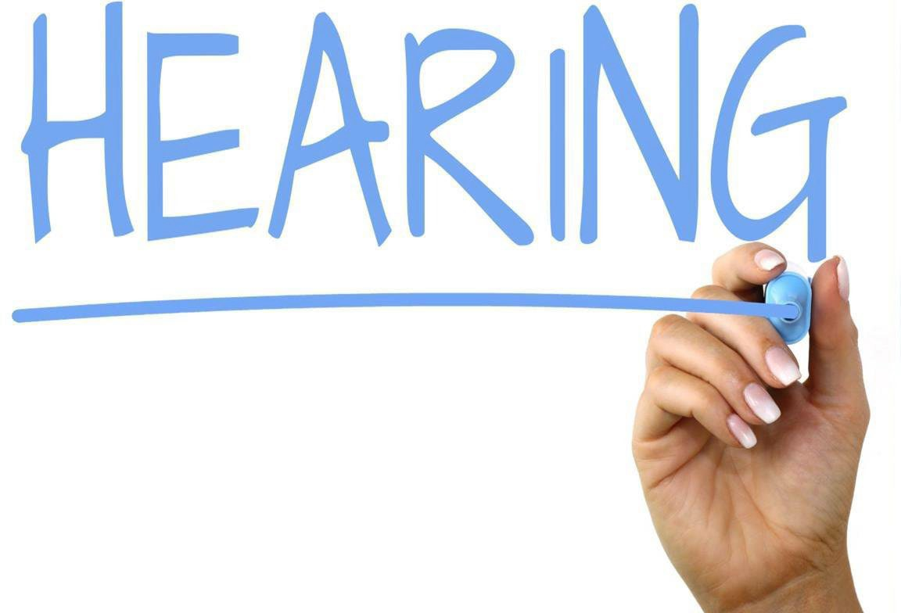
The Echols County Board of Commissioners will be holding a Public Hearing Tuesday September 24, 2024, at 10AM and 6PM at the Echols County Board of Commissioners oﬃce.
An additional public hearing to adopt the millage rate will be held Tuesday October 1,2024, at the Echols County Board of Commissioners at 1PM.

