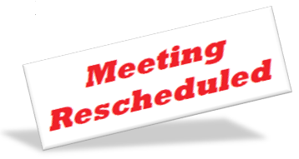

Due to a scheduling conflict, The Hazard Mitigation meeting that was scheduled for Tuesday September 24,2024 at 6:30 PM has been canceled.

A new date and time will be announced at a later date.